TWO FACTOR AUTHENTICATION

Abstract
Two-Factor Authentication (2FA) is a security mechanism designed to protect user accounts by requiring two different forms of authentication before granting access. Traditional username-and-password authentication is vulnerable to attacks such as password guessing, phishing, credential theft, and brute-force attacks. A 2FA system improves security by combining something the user knows, such as a password, with something the user possesses, such as a mobile phone or authentication application.
This project presents the design and implementation of a Two-Factor Authentication system. The system first verifies the user's username and password and then requires a second authentication factor, typically a One-Time Password (OTP). The OTP is generated and sent to or displayed through an appropriate authentication channel and must be entered within a limited period. Only after successful verification of both factors is the user granted access.
The project demonstrates how two-factor authentication can provide an additional layer of protection against unauthorized access and improve the overall security of web-based applications.

Introduction
With the increasing use of web applications and online services, protecting user accounts has become an important security requirement. Password-based authentication alone is often insufficient because passwords can be stolen, guessed, reused, or obtained through phishing attacks.
Two-Factor Authentication addresses this problem by requiring two independent authentication factors. The first factor is generally a password, while the second factor may be an OTP, authentication application, hardware token, biometric factor, or another trusted device.
In this project, a user must successfully complete both authentication stages before accessing the protected application. This approach significantly reduces the possibility of unauthorized access when a password is compromised.

Objectives
The main objectives of this project are:
- To develop a secure user authentication system.
- To implement two independent authentication factors.
- To generate and validate One-Time Passwords.
- To prevent unauthorized users from accessing protected resources.
- To ensure that OTPs are valid only for a limited period.
- To improve the security of conventional password-based login.
- To demonstrate the practical use of multi-factor authentication.

System Architecture
The system consists of the following major components:
- User Interface – Provides login and OTP verification screens.
- Authentication Server – Validates credentials and manages authentication requests.
- User Database – Stores required user account information securely.
- OTP Generator – Creates a temporary authentication code.
- OTP Delivery Mechanism – Delivers or displays the OTP using the selected authentication method.
- OTP Verification Module – Checks whether the submitted OTP is valid and has not expired.
- Protected Application – Provides access only after successful authentication.

Working Procedure
The complete working process is as follows:
- The user opens the application's login page.
- The user enters their username and password.
- The server validates the credentials.
- If the credentials are incorrect, access is denied.
- If the credentials are correct, the system initiates the second authentication factor.
- A temporary OTP is generated.
- The OTP is delivered through the configured authentication mechanism.
- The user enters the OTP.
- The system validates the OTP and its expiration time.
- If the OTP is correct, the user is authenticated.
- The user is granted access to protected resources.
- If the OTP is incorrect or expired, authentication fails.

Modules of the Project:
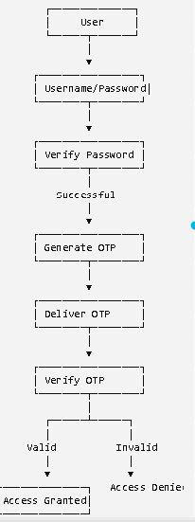
Methodology
- User Registration
User creates an account with username, email, and password.
- User Login
User enters username and password.
- Password Verification
System checks whether the password is correct.
- Generate OTP
If the password is correct, the system generates a 6-digit OTP.
- Send OTP
OTP is sent to the user's registered email/mobile.
- OTP Verification
User enters the OTP. The system checks whether it is correct and not expired.
- Login Successful
If both password and OTP are correct, the user gets access to the dashboard.
Expected Outcomes
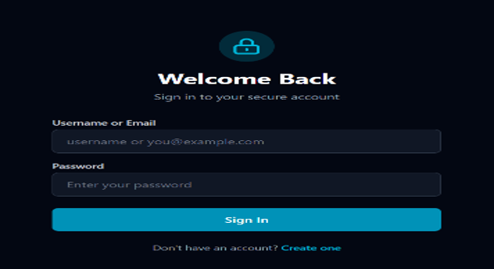
Login page

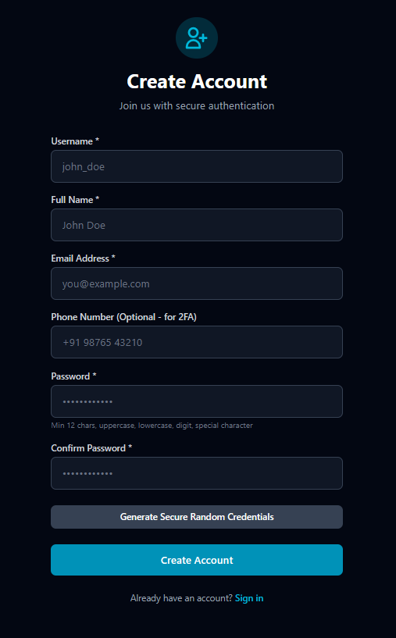
Verification Page
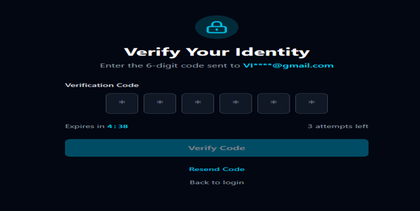
Conclusion
Two-Factor Authentication (2FA) provides an additional layer of security by requiring two different methods to verify a user's identity. Even if a password is stolen, the attacker cannot easily access the account without the second verification factor, such as an OTP.
This project demonstrates that 2FA can significantly improve account security, reduce unauthorized access, and protect sensitive user information. Therefore, implementing 2FA is an effective and practical approach for building more secure authentication systems.

